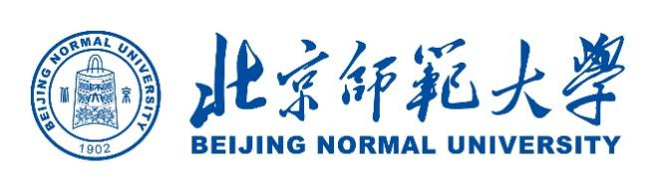
2025 CAMPUS Asia Plus P2 Short-term Study Abroad Program at BNU (Tentative Program Schedule)
September 18-26,2025
 | Date | Contents
Day 1 | Thursday  September 18th | Visiting students and staff leave home country for China (Beijing)  Check-in at accommodation  Pre-program session
Day 2 | Friday  September 19th | AM: Program Orientation and Campus tour  PM: Lecture (Chinese language and culture)
Day 3 | Saturday  September 20th | Practical activities (Field trip)
Day 4 | Sunday  September 21st | Practical activities (Field trip)
Day 5 | Monday,  September 22nd | AM: Lecture (Geography and sustainability)  PM: Lecture (Chinese education system)
Day 6 | Tuesday,  September 23th | Free day
Day 7 | Wednesday,  September 24th | AM: Lecture (Chinese education)  PM: Company visit
Day 8 | Thursday  September 25th | AM: Preparation for the final presentation  PM: Final presentation and wrap-up
Day 9 | Friday  September 26th | Visiting students and staff leave Beijing for home country
*This course will be conducted entirely in English.
*The program itinerary is subject to change.

